Alumni Association 2019 -20

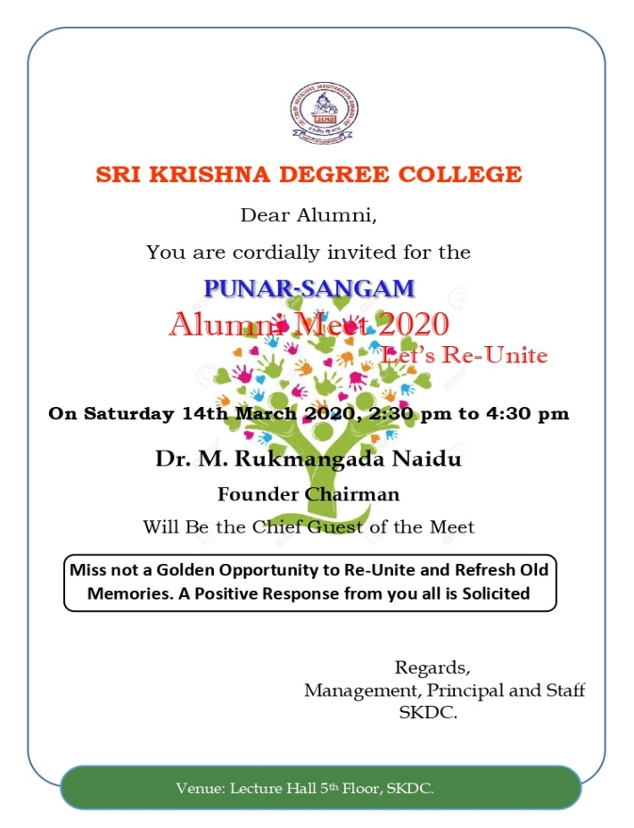

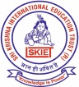
Sri Krishna Degree College
Affiliated to Bangalore University, NAAC Accredited
ALUMNI MEET 2019-2020
Programme List
- Invocation : By Siddique,
I year B.com

- Welcome Speech : By Dr. Manjula Prasad
HOD Department of Computer Science

- Lighting the Lamp :By Dignitaries

- A talk on significance of Alumni Meet :By S P Manohar,
Academic Director, SKDC

- Opinion Sharing : By Alumni

- Chief Guest Address : By Dr. M. Rukmangada Naidu,
Founder Chairman SKIES

- Speech : By Prof. Venugopal,
PG Director

- Presidential Address : By Dr. Ushakumari N,
Principal SKDC

- Vote of Thanks : By Mr Ravi N,
HOD Department of Commerce

- National Anthem followed by High Tea

Programme Comparing by Mrs. Deepa K,
HOD Department of Management
ALUMNI MEET 2019-20 REPORT
Sri Krishna Degree College Alumni Association registered under District Registrar Societies, Second Zone Bengaluru on 29.2.2020.
Sri Krishna Degree College Alumni Meet 2019-20 was held on 14th March 2020 at 2:30 PM. The program was held in Silver Jubilee Building. It was started with Welcome speech by Dr. Manjula Prasad, HOD Computer Science Department, followed by lighting of lamp. This year more than 250 Alumni were present.
Beloved Academic Director, Prof. Manohar S P, give brief introduction about the programme and its requirement. Dr. Usha Kumari N, Principal SKDC address the gathering and Mr. Rukmangada Naidu Founder Chairman of SKIET, gave the presidential address and shared his views about the alumni. Mr. Venugopal, Director PG and Mr. Changappa C T, Principal SKD Evening College also addressed the gathering.
Some of the Alumni shared their views about the college and programme. All of the Alumni were happy and promised to join the further alumni meet which will be arranged the organisation formed for the purpose. Finally vote of thanks was given by Mr. Ravi N, HOD, Department of Commerce. The programme was hosted by Deepa K, HOD department of Management.
This year Alumni Association formed Committee of Alumni with Mrs. Babitha of 2007-10 batch as President and Mr. Venugopal of 2012 -15 batch as vice president and other members like Mr. Harsh, Mrs. Ramya, Mr. Sathyprasad, Mr. Suraj, Mr. Sai Akhil, Mr. Varun, Mrs. Nayana, Miss Shruthi, Miss. Megana were selected. These members were asked to organise the coming alumni meet and help the institution in providing financial assistance and job related aspects.
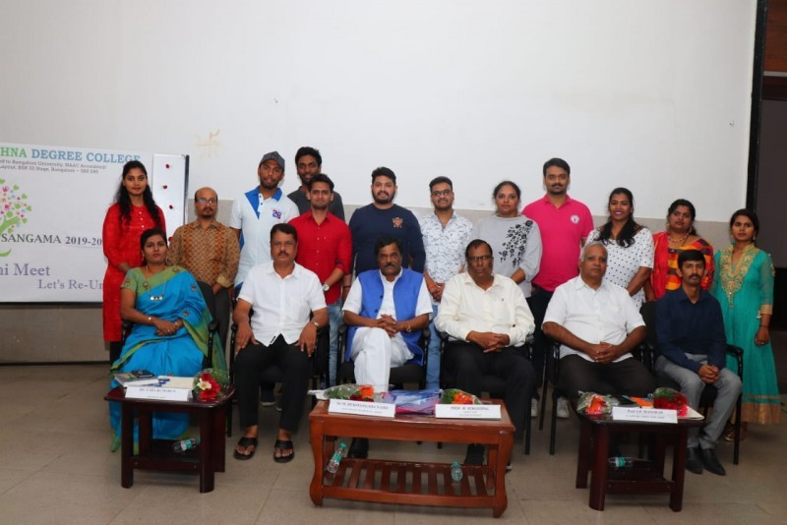
Alumni Association Committee Member with the Dignitaries
Photos of the Programme
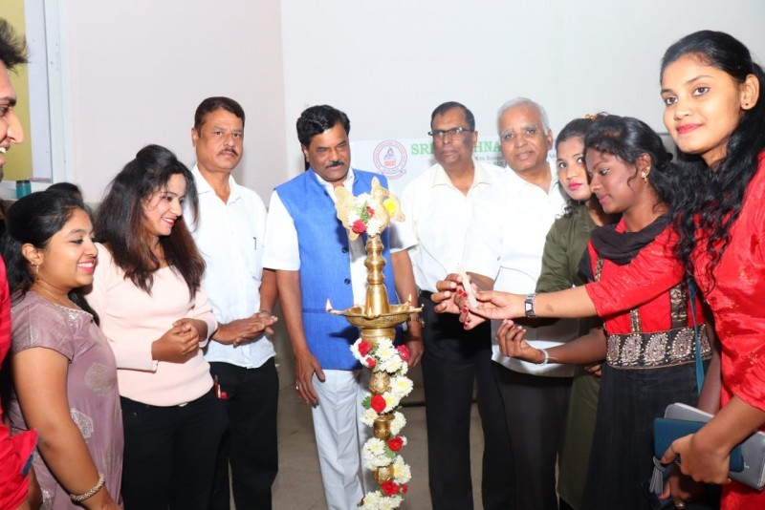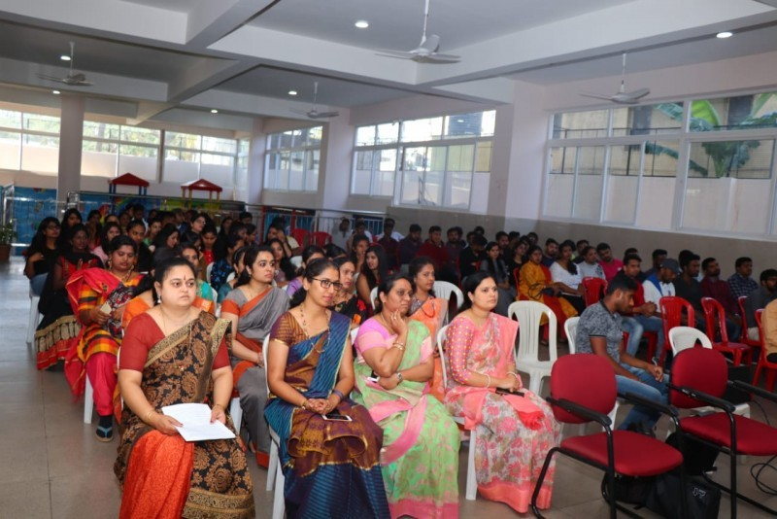

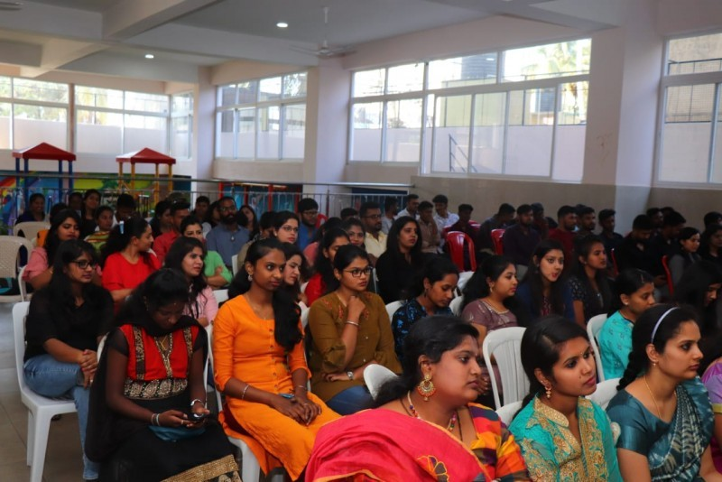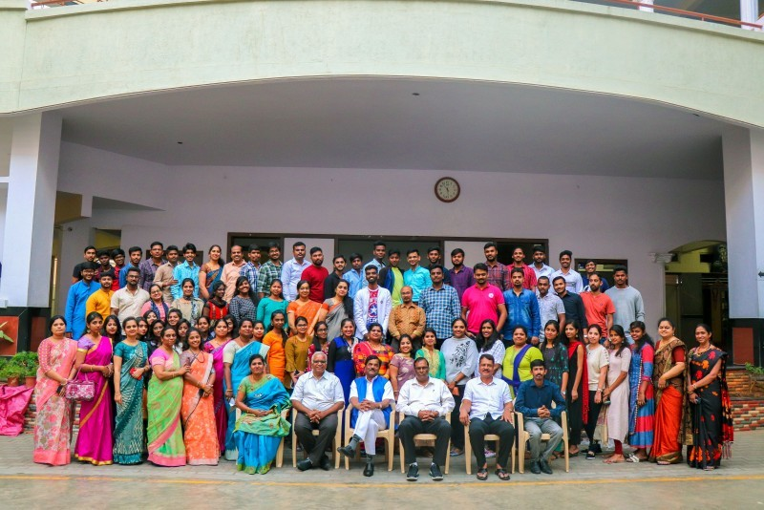
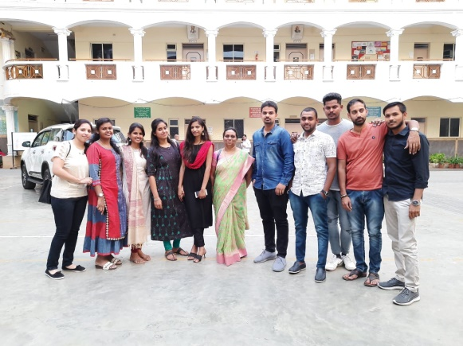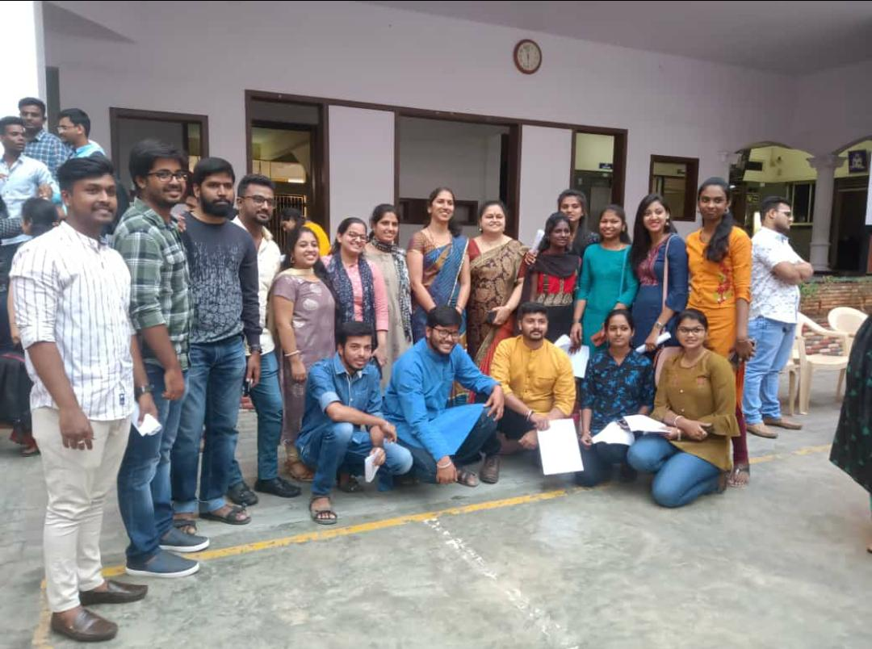

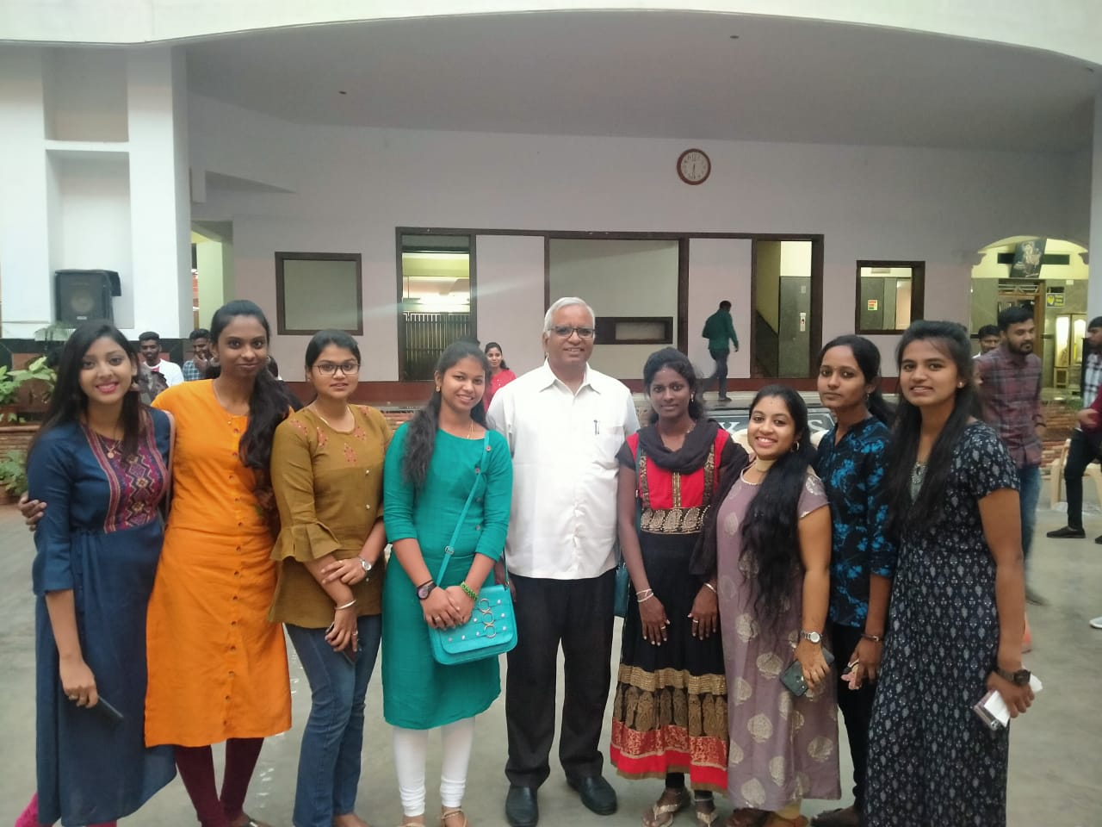
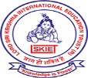 Sri Krishna Degree College
ITI Layout, BSK 3rd Stage, Bangalore- 560085
ISO certified and NAAC Accredited ‘B’ Grade
PUNAR-SANGAM - Alumni Association ®
List of Committee Members
President: | Mrs. Babitha | 9686679885
Vice President: | Mr. Karthik M R | 7996636628
Secretary: | Mr. Venugopal | 9901011120
Joint Secretary: | Mrs.Nayana | 7899673588
Members: | Mrs. Ramya  Mr. Satyaprasad  Mr. Harsha  Mr. Suraj  Mr. Sai Akhil  Ms. Meghana  Mr. Varun  Mr. Girish  Ms. Shruthi B | 9986148393  8904668101  9632077895  9901455896  8123864818  8050367955  9902620181  8553536670  9632012464

