Sri Krishna Degree College
Alumni Association
Report 2020-21
Due to Covid 19 online meeting was conducted to discuss about what are the things we can do for the academic year 2020-21. On 28th March 2021 we conducted a 1st meeting with the selected alumni member and decided to conduct various progremmes by the alumni for the students. And also involve the alumni in the various college programme.
This year nearly 170 students were registered for the Alumni Association. And collected ₹ 17,000 as a registration fee from the members.
Alumni’s were involved in the judgement for the selection of best performance and Mr/Miss Fresher in the Inauguration of Cultural activities for the academic year 2020-21, and Fresher’s Day which was held on 13th of January 2021.

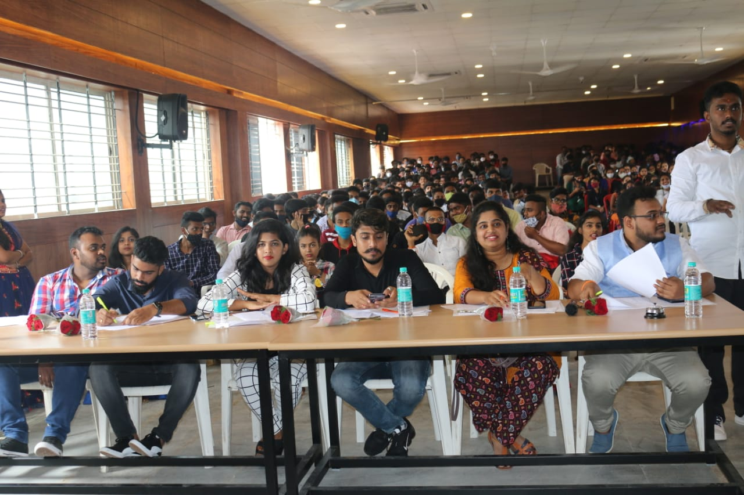
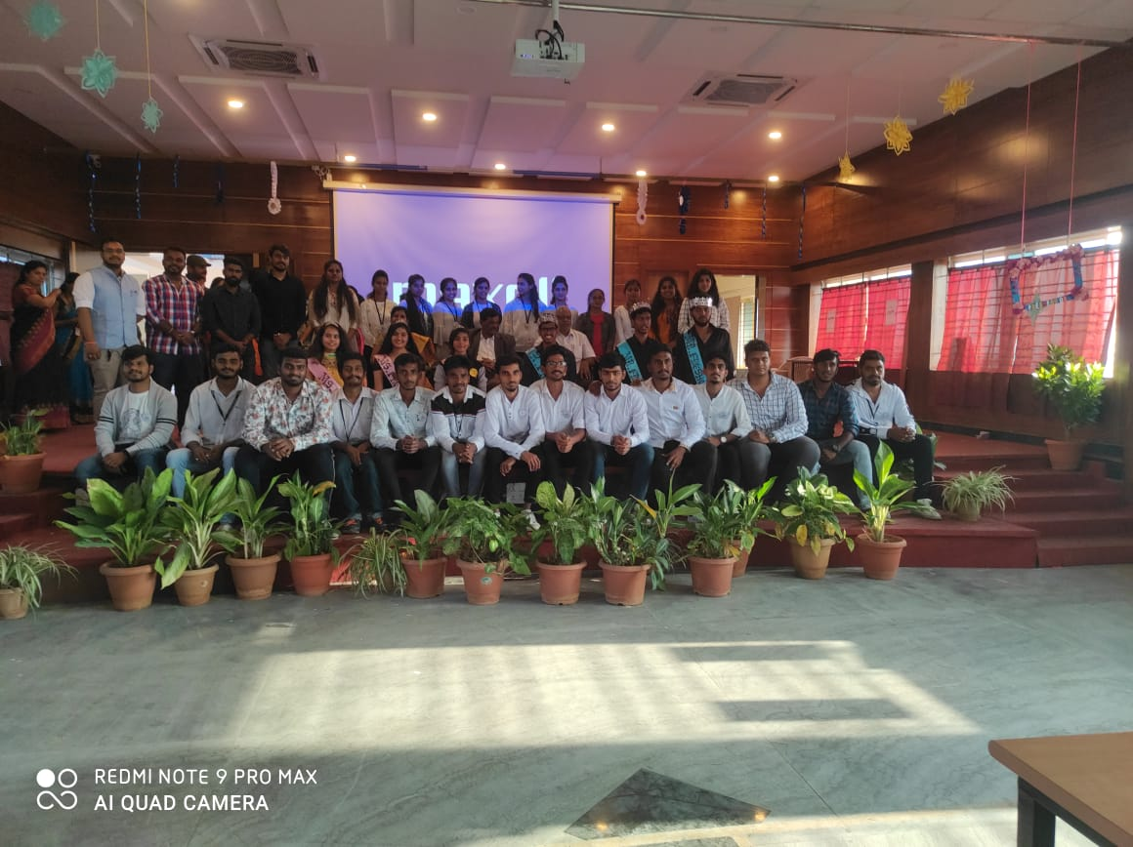

Student Webinar on the topic COLLEGE TO CORPORATE: TIPS AND TRICKS was organized on 22 -05-2021 by Mr. Harsha K V, Key Accounts Manager, Razorpay, ALUMNI SKDC. The Webinar was presented through Google Meet Platform for Final year B.com, BBA, BCA,

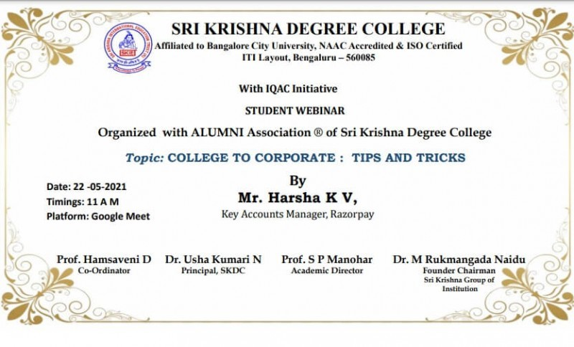

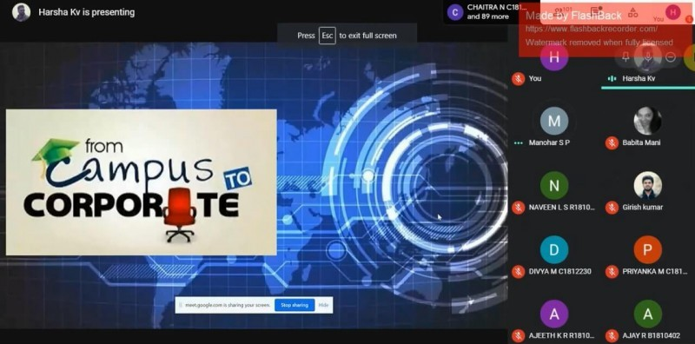

BCA Dept. conducted the webinar on “Cloud Technologies” on 5th of June 2021. Our Alumni Mr. Madhvesh M L Senior Associate consultant of Eli Lilly Pharmaceutical gave the information on Cloud Technologies using the Google Meet platform for the students & faculty members.

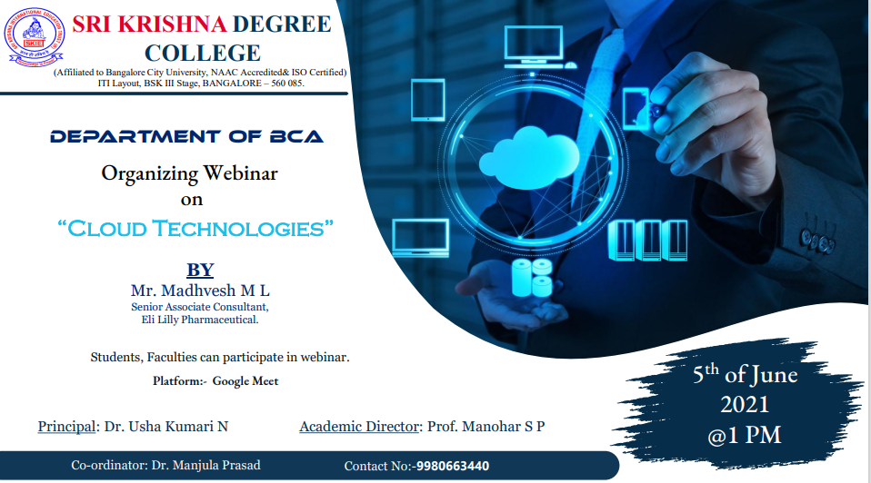
Many more programmes to enlighten and encourage the students will be arranged in the next academic year by inflowing all the alumni of our institution.

